Merseyside County AA Cross Country Championships
Stadt Moers Park, Knowsley, Jan 4th 2014
Car Parking

As well as the limited parking at the park, there will be a secure car park available in Stretton Way, opposite the Knowsley Council Depot. From Junction 6 of the M62, take the A5080 signposted Huyton , turn right into Wilson Road and then first right into Stretton Way and follow it to the car park, which will be sign posted. From here it is an 800m walk under the motorway into the park, past the lake to the start and finish area. (see map below).

Those arriving after 11am should use this car park to avoid congestion at the park.
Please make sure your Senior runners are aware of this arrangement.

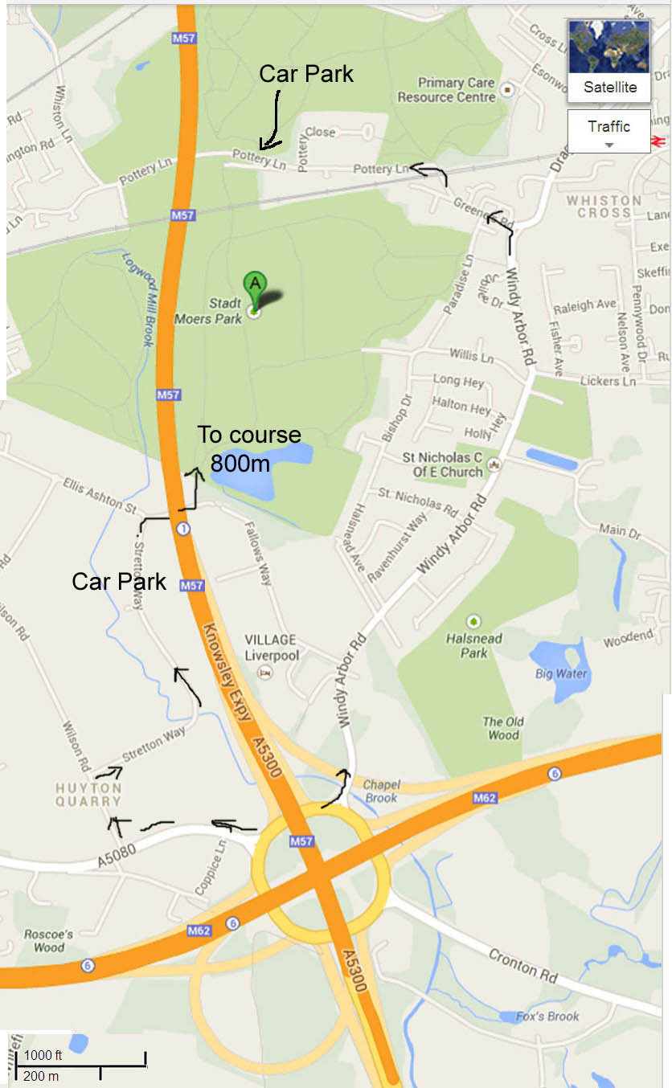
Merseyside County AA Cross Country Championships
Stadt Moers Park, Knowsley, Jan 4th 2014
Timetable and Course map

The timetable is as advertised on the prospectus

Large lap 3km : Medium lap 2km : Small lap 1 km

10.45 9&10 Boys & Girls Start->part large lap (see map) 1.5km
11.00 U13 Girls 1 large lap 3 km
11.20 U13 Boys 1 large lap 3 km
11.40 U15 Girls 1 small + 1 large lap 4 km
12.00 U15 Boys 1 small + 1 large lap 4 km
12.25 U17 / Junior Women 1 medium + 1 large lap 5 km
12.50 U17 Men 1 medium + 1 large lap 5 km
13.15 Senior Women 1 medium + 2 large laps 8 km
14.05 Junior Men 1 medium + 2 large laps 8 km
14.05 Senior Men 1 medium + 3 large laps 11km

