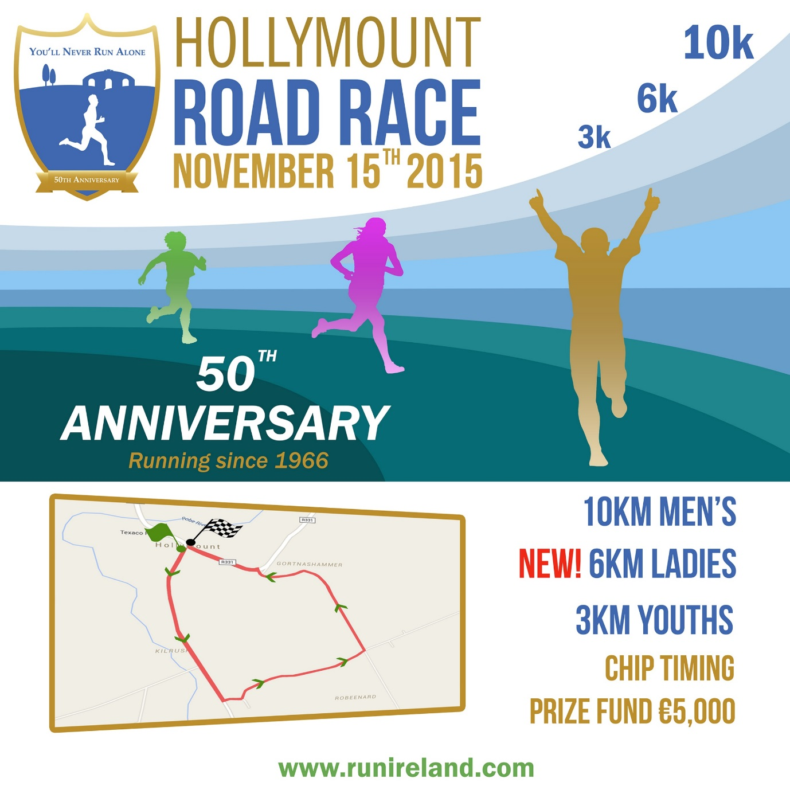
https://www.facebook.com/HollymountRoadRace/

Liverpool has been represented in both the Men’s and Ladies races over the last 40 years.
The anniversary event is a not to be missed opportunity to visit Dublin, experience traditional Irish hospitality and compete on a very fast course with pb potential.
This year’s trip costs £150 pp and includes travel, accommodation in Dublin and Hollymount, food and race entry. Depart 11am Friday 13th Nov and return early hours Mon 16th Nov.
Demand is high – please book early with a £50 deposit by Tues, 20th Oct.
All those interested please contact Robbie Woods or Neil Chester directly for further details.
Neil’s contact details are as follows: n.chester@ljmu.ac.uk; 07870567122

