**Welcome to Liverpool Pembroke and Sefton Harriers Athletics Club**

**Who are we?**

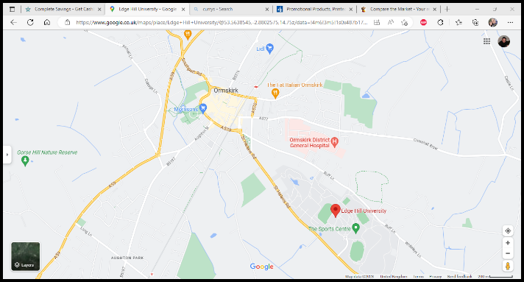Liverpool Pembroke & Sefton was formed in 1995, by the merger of two long established athletic clubs; Liverpool Pembroke (formed in 1890) and Sefton Harriers (formed in 1889). We’ve been based at Edge Hill University since1997 and train at the sports centre and track on campus.

We cater for athletes of all abilities from the age of 10 through to veteran status and the club has a growing membership with athletes joining us primarily from across West Lancashire, Merseyside, and the University.

During the season athletes have opportunities to train twice a week and compete in organised events and competitions covering:

* Track and field athletics
* Cross country running
* Road running
* Fell running

We compete as teams and individuals across leagues, regional, and national championships in addition to many other events up and down the country that our athletes participate in.

The club and its members have individual honours and team titles both locally, at county level and nationally with several of our athletes achieving international selection and representation in European and Olympic games. We are an inclusive club and encourage athletes of all abilities.

**Our Vision**

*“To be a highly successful club, which regularly competes at national level, develops and attracts athletes of all disciplines to optimise their potential in a safe and inclusive environment”.*

**Our Values and Principles – What’s important to us**

We believe that it’s important to have values and principles, at LPS we live by these.

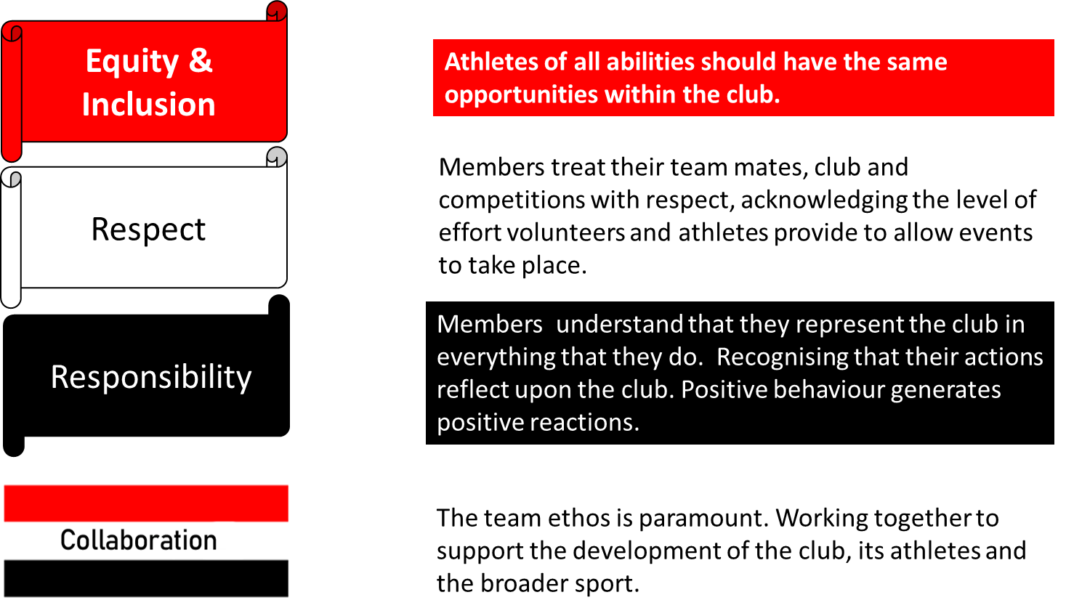

We’re a community based club and encourage support for community events such as Parkrun and junior Parkrun. Our members regularly participate and volunteer at these events to help ensure that they can continue. On occasions we will seek volunteers to help us complete a “Parkrun takeover” where we will provide marshals, time-keepers and pacers for the whole event.

**Key Contact Information for the Club**

* Club website : <http://www.lps-athletics.co.uk>
* Club welfare and registration enquiries : [clubwelfare.lps@gmail.com](mailto:clubwelfare.lps@gmail.com)
* List of club officers : [click here](https://www.lps-athletics.co.uk/officers/) or go to www.lps-athletics.co.uk/officers



@pembrokesefton

Image result for instagram logo@ liverpoolpembrokesefton

@LPSAthleticclub



We use whatsapp to communicate – Please ask for a code upon registration

**Key Information For Members**



**Training**

We train every Tuesday and Thursday evening at Edge Hill University, St Helens Road, Ormskirk L39 4QP. Training starts at 6:30 with sessions finishing between 7:30 (track) and 8:00 (Field).



**Competing**

We are a competitive athletics club and expect members to represent the club in competitions several times each season. We do, however, understand that people have other commitments and are unable to attend every event.



**Where do you compete?**

We are members of the [midlancs league](http://www.midlancs.org.uk/) ([www.midlancs.org](http://www.midlancs.org)) who typically host competitions in Lancashire and Merseyside, though on occasions in Cumbria. In most instances events are within 45 mins drive of Edge Hill University.

We are also members of [Northern Athletics](http://www.northernathletics.co.uk/) (www.northernathletics.co.uk) who host a number of events throughout the year and the Liverpool & District cross country league.

We welcome and encourage athletes of all abilities to take part in these events.

Members also have the opportunity to compete at representative level if they perform well in regional events. These events could be anywhere in the country and are always great occasions.

**How much does it cost to compete?**

If you are competing for the club in a Mid Lancs league event or one of the Northern league events then there is no charge. The club pay fees for these each year. If you are entering an event that is not organised by the club then you will need to register and pay entry fees yourself.

**Club Vests**

When you are competing for the club it is necessary to wear a club vest. You won’t be able to compete without one.

If you are competing in an event that the club is not registered for then it isn’t compulsory to wear a club vest but as the club name is recorded against yours, we would prefer you to represent the club in our club vest.

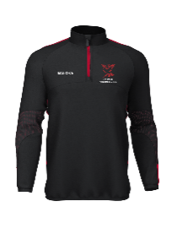

**LPS branded clothing**

We’ve teamed up with Malooka Sports who supply a great range of LPS branded clothing. Click [here](https://www.malookasports.com/product-category/teamwear/liverpool-pembroke-sefton/) or go to [www.malookasports.com](http://www.malookasports.com) and search for LPS . We can provide you with the password for the club shop.

**Club Membership and Track Fees**

The season runs from 1st April to 31st March and membership fees are paid annually. The fee covers the cost of registration with England Athletics, the leagues in which we compete including race entry fees, plus general administration of the club. These are payable at the club or by bank transfer (please ask for details). Online facilities will also be available via our website shortly.

You aren’t able to compete for LPS unless you have registered and paid the membership fee. In addition to the annual membership, there are fees per session with options to pay quarterly. Our fees are broken down below.

| **Membership Category** | **Age** | **Membership Fee** |
| --- | --- | --- |
| Junior | Age 10-19 (over 10 on 31st Aug) | £40.00 |
| Senior | Age 20 & Over | £40.00 |
| EHU Student | Enrolment proof is required | £20.00 |
| Family Discounts | Sibling is a fully paid member | £20.00 |
|  | Parent is a fully paid member | £20.00 |
| Second Claim | Any | £20.00 |

**Track fees**

Training costs £4 per session, alternatively Track Fees of £35 can be paid quarterly. A discount down to £15 is available for any second or subsequent children from the same household.

**Additional costs**

Athletes are expected to compete in club colours therefore it is necessary to purchase a club vest. Currently these are priced at £18.

Events not hosted by Mid Lancs or Northern Athletics require the athlete to pay individual race registration fees.

**Safeguarding**

Our club provides an inclusive and safe environment, all our coaches are DBS checked. As a club we subscribe to the England athletics [Club Welfare and Safeguarding guidelines](https://www.englandathletics.org/clubs-and-facilities/club-support-services/club-welfare/).

**Policies & Governance**

Other policies and our constitution are available upon request or by going to our [policies](https://www.lps-athletics.co.uk/governance-policies/) section on the web site.

**Still Thinking About Joining Us?**

We’d love to see you at LPS. Athletes and volunteers of all abilities are welcome to join in with sessions before becoming a member. We usually invite athletes to become members a month after they start training with us.

**Why Should I Become a Member?**

**The following benefits are included in your membership fee:**

* 6 free Cross Country races per year (Mid Lancs League)
* 4 free Cross Country races per year (Liverpool Disctrict League) \**Senior Only*
* Free entry to County, Northern & National Cross Country races
* Reduced entry fee at all road races by £2, with England Athletics affiliation
* Training sessions with a qualified coach
* Opportunity for club place at London Marathon
* Opportunity to compete in Northern Senior T & F League
* Opportunity to run in Road, Fell & Cross Country relay races
* Opportunity to compete in our club championships for Road, Cross Country & Fell running
* Annual Track & Field Club Championship weekend

**Additional Benefits for Junior Members**

* Opportunity to compete in Mid Lancashire Track & Field League
* Development of all round athletic ability with good ratio of coaches to athletes
* Coaching in specialist events – throws, jumps, hurdles, sprints, endurance
* Become part of a team
* Can link in to Duke of Edinburgh awards
* Learn new skills
* Gain confidence
* Enrolment into our “Rising Stars” recognition scheme

**Advantages of joining Liverpool Pembroke Sefton include:**

* Make new friends
* Social runs and activities
* Help and advice on training, fitness and races
* Run with friendly groups
* Can run with others of similar standard and develop by learning from others.
* Running with a club helps you to train & recover better
* Friendly support & encouragement at club sessions
* Travel to races with club mates & reduce costs
* A chance to represent your county or compete nationally.
* LPS Strava Club
* Progression monitoring via poweroften and runbritanrankings.

**Senior Membership (age 20+)**

All interested senior athletes are welcome to come and try a few sessions with us. Please complete the membership enquiry form [online](https://www.lps-athletics.co.uk/join-lps/) and we will invite you down sessions and ensure someone is there to meet you. Once you have been coming for about a month we will invite you to join the club and collect membership fees,

**Junior Membership (age 10 to 19)**

Membership for Track & Field training is open to everyone from year 6, minimum age 10. Due to safeguarding and health & safety requirements we have to limit the number of Junior members at any one time. This means that when you register your young person’s interest we’ll place them on a waiting list until places become available. This is usually relatively quick.

Please complete the membership enquiry form [online](https://www.lps-athletics.co.uk/join-lps/) or email [clubwelfare.lps@gmail.com](mailto:clubwelfare.lps@gmail.com) (Lesley Jackson, our Young Athlete Co-ordinator) and we will contact you to confirm receipt and then arrange a start date.

Please note, all of our young athletes are expected to take part in competition for track & field and/or cross country throughout the year.

**Volunteer with Us**

There is always a place for non-athletes and volunteers at Liverpool Pembroke & Sefton. In fact we cannot run the club without volunteer support. We are an inclusive club and always welcome any parents or friend who may wish to become involved in club activities such as coaching, officiating or helping to keep the club running.

If you are interested in volunteering with our club please register via our website <https://www.lps-athletics.co.uk/volunteer/> , click [here](https://www.lps-athletics.co.uk/volunteer/) or call and see us on Tuesday or Thursday at Edge Hill and we will discuss further.

We look forward to you joining us in the near future.

